John Rollinson

CS151, Spring 2020

Module 14 Review Questions:

These questions are taken from Chapter 17 (9th edition) or Chapter 18 (10th edition) of our textbook:

11. Write a function that returns the value stored in the last node of a nonempty list passed to it as parameter. The function should print an error message and terminate the program if the list passed to it is empty. (See included reviewQuestions.cpp for definition of the function.)

**double lastValue(ListNode *ptr)**

12. Write a function that is passed a linked list as parameter and returns the tail of the list: That is, it removes the first node and returns what is left. The function should deallocate the storage of the removed node. The function returns **null** in **ptr** if the list passed to it is empty. (See included reviewQuestions.cpp for definition of the function.)

**ListNode * removeFirst(ListNode *ptr)**

13. Write a function that concatenates the items in **list2** to the end of **list1** and returns the resulting list. (See included reviewQuestions.cpp for definition of the function.)

**ListNode * listConcat(ListNode *list1, ListNode *list2)**

For each of the following program fragments, predict what the output will be

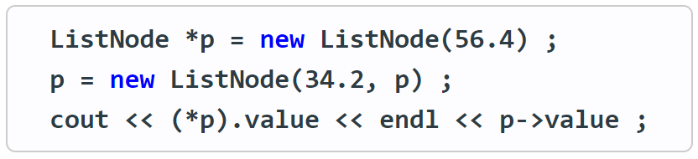14.

The output is:

56.4

34.2

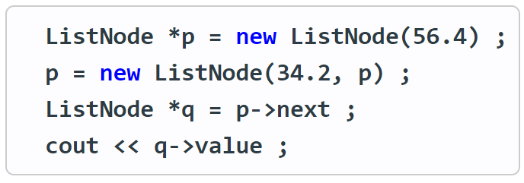15.

The output is:

56.4

16.

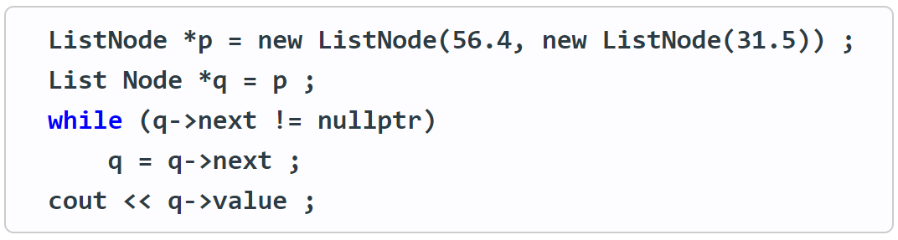

The output is:

31.5